**Assignment 5: OSPF & EIGRP**

**Name : Pritesh Gandhi**

**Commands**

**Switch Commands**

|  |  |
| --- | --- |
| **Commands** | **Description** |
| vtp mode client | Set the switch mode to vtp client |
| vtp domain INETLAB | Set the vtp domain to INETLAB |
| Vtp password cisco | Set password to vtp database |
| show vtp status | Display the vtp configuration |
| Interface [port] | Go into interface configuration mode |
| Switchport mode trunk | Set the port mode to trunk for enabling VLAN traffic over it |
| switchport trunk allowed vlan [vlan_number] | Specifying which VLAN are allowed to send the frames over the trunk port |
| switchport mode access | Set the port mode to access for enabling VLAN access |
| switchport access vlan [vlan_num] | Assign VLAN to the port for sending frames of that VLAN over the network |
| Vlan [vlan_num] | Create a vlan |
| Name [vlan_name] | Assign a name to the vlan |
| Show vlan | Displays all the vlans & the ports assigned to them |
| Int vlan [vlan_num] | Create a layer 3 vlan interface |
| ip address [ip_addr][mask] | Assign an IP address to the interface |
| Spanning-tree portfast | Enable portfast on the interface |
| Show spanning-tree int [port] portfast | Displays the vlans allowed on the port for portfast |
| No switchport | By default, a port on layer 3 switch acts as a layer2 switch so to make it into layer 2 physical port, use this command |
| **Router Commands** |  |
| Router eigrp [Autonomous System number] | Enable eigrp on the router. Assign an autonomous system number which will be used for configuration throughout the network |
| network [network addr] [wildcard mask] | Specify the network to be advertised throughout the network dynamically |
| router ospf [process id] | Enable the ospf protocol on the router with specific process id |
| network [network addr] [wildcard mask] area [area num] | Specify the network to be advertised on the network using ospf with the area to which it belongs |
| show int [port num] | Displays the port configuration( which helps for redistribution) |
| redistribute ospf [process id] metric [bandwidth ][delay] [reliability] [load] [MTU] | Enable redistribution of OSPF route to EIGRP route which requires all the metric values : bandwidth, delay in 10 microseconds, reliability, load, MTU( which we can get from above command) |
| Redistribute eigrp [AS] metric-type [type] | Enable redistribution of EIGRP route to OSPF route which requires Autonomous System number of EIGRP & type of metric (1 or 2) |
| Show ip ospf neighbor | Diplays the adjacent routers with info : priority,state(DR/BDR),interface address connected to current router |
| Show ip route | Displays all the routes to which the router can communicate with metric value, feasible distance |
| show ip [protocol name] topology | Displays the routes available to all the networks with successor(current best path) and feasible successor(next best path). |
| [no] Ip domain-lookup | Enable or disable the domain-lookup |
| Interface [port].[subinterface num] | Create a sub-interface on the physical port |
| encapsulation dot1Q [vlan num] | Enable encapsulation with IEEE 802.1Q protocol for specific VLAN |
| ip address [ip_addr][mask] | Assign an ip address to the port |
| Interface [port] | Go to configuration mode for the specified port |
|  |  |
|  |  |

**Results:**

**PC :**

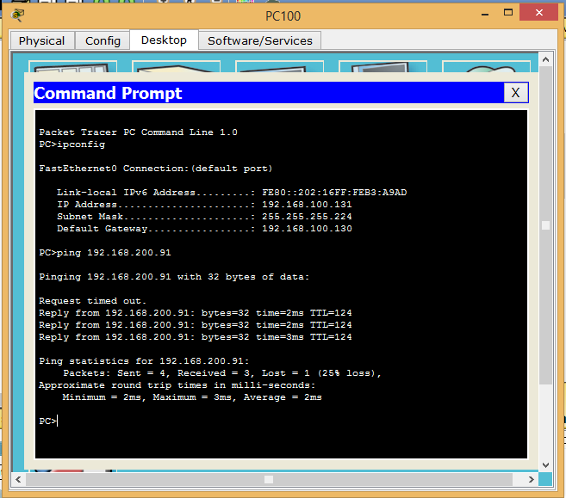

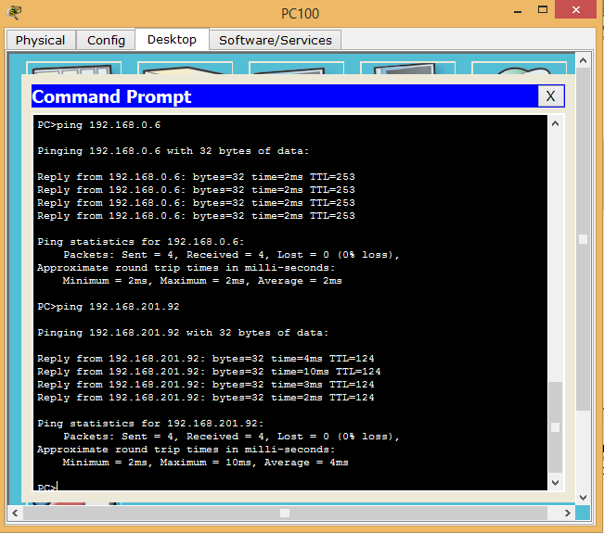

**Router-Dallas :**

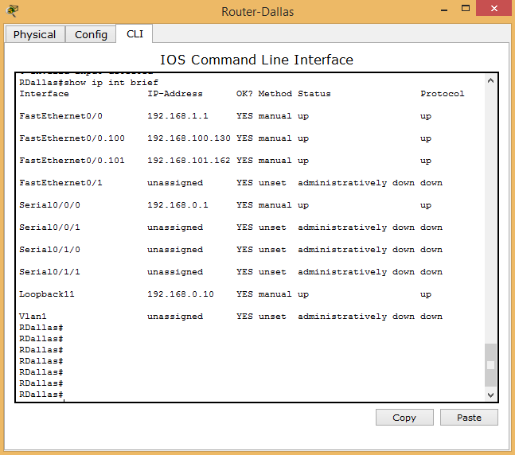

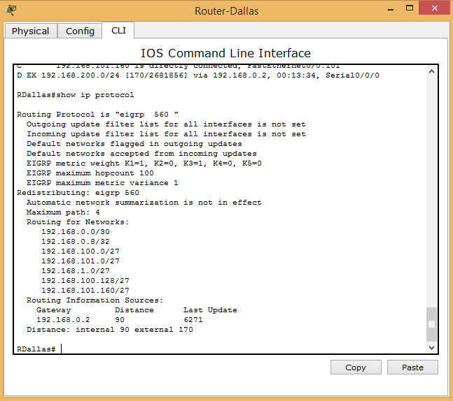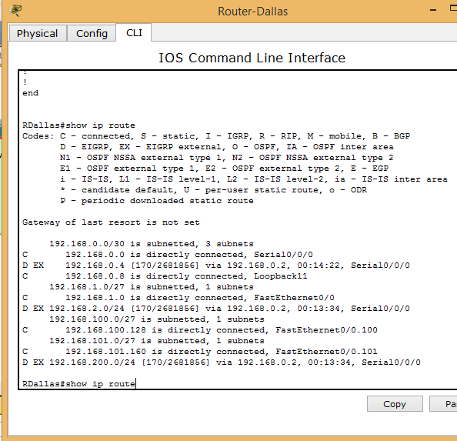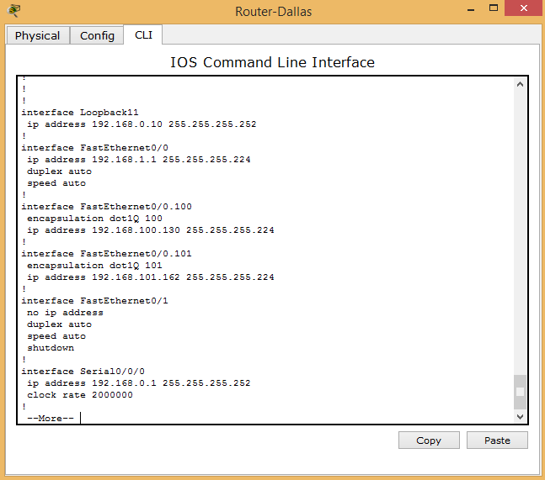

**Router-New York**

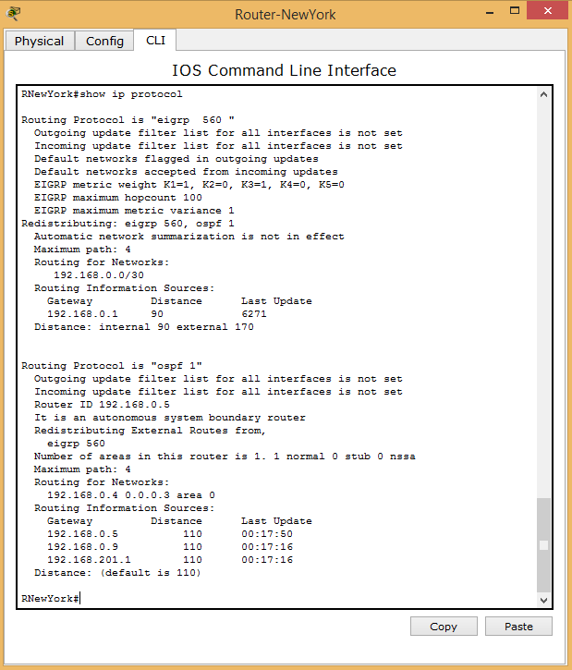

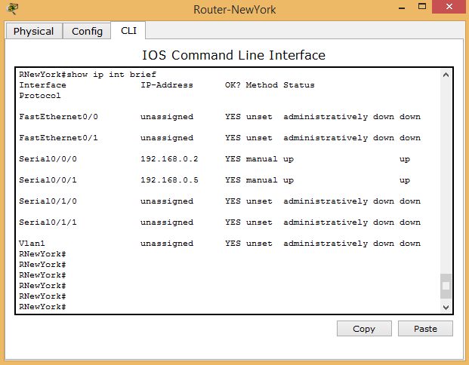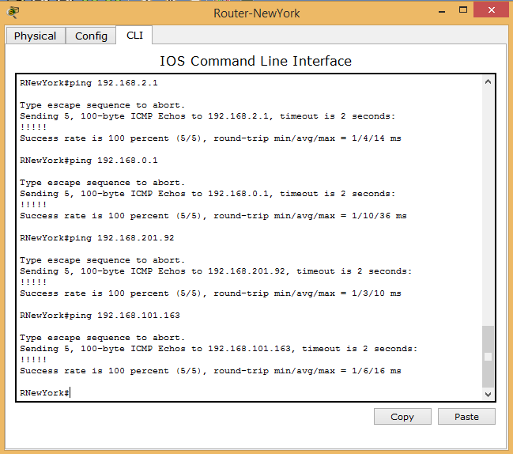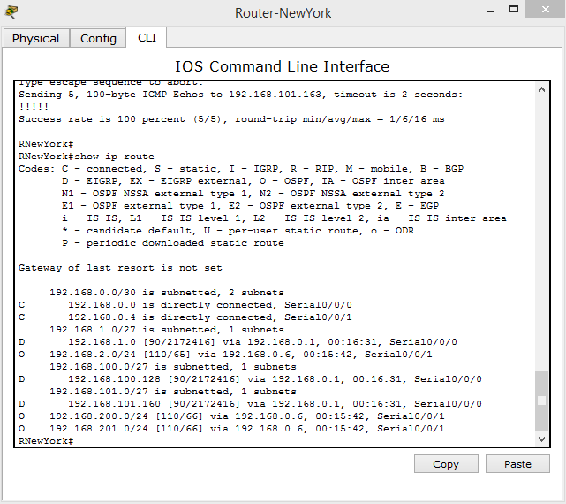

**Router-Chicago:**

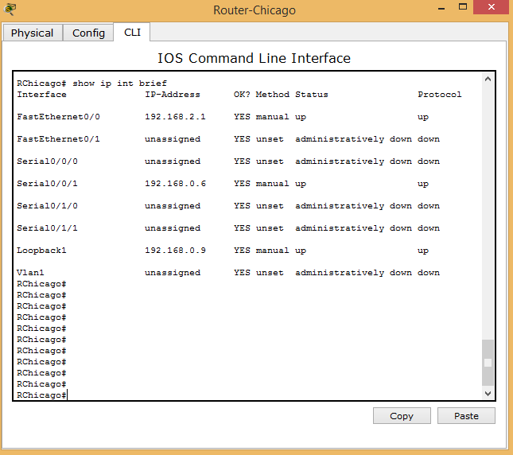

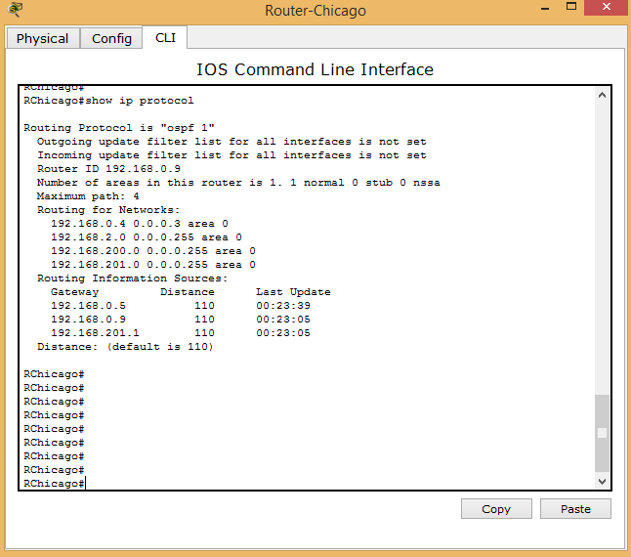

**Switch1-Chicago:**

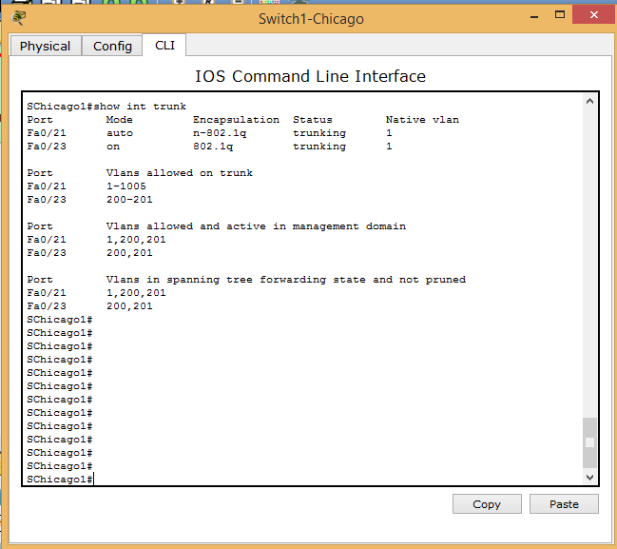

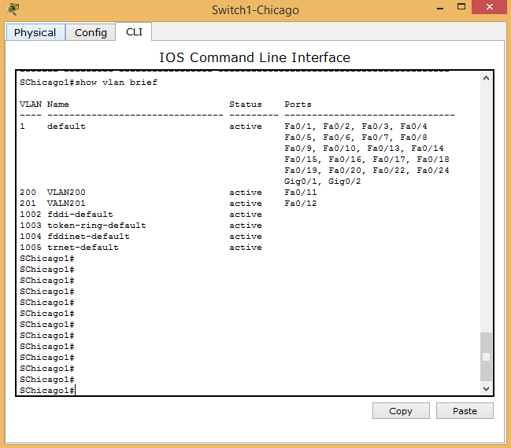

**Switch2-Chicago:**

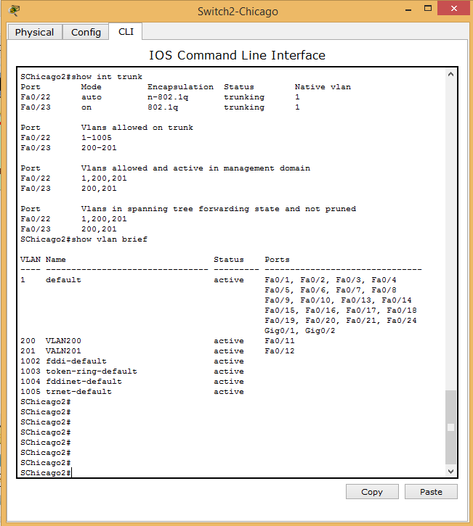

**Switch-L3-Chicago:**



